# Article ID: [3215] Filter Alarm Icon keeps blinking after filter replacement

**Article name:** Filter Alarm Icon keeps blinking after filter replacement

**WSS**

**Article Content:**

The filter life depends on the amount of use. We recommend you to replace the filter at least once

every 6 months. When attaching the filter place it to an easily accessible place (for removal and replacement).

After 6 months of first power input the icon  will start blinking.

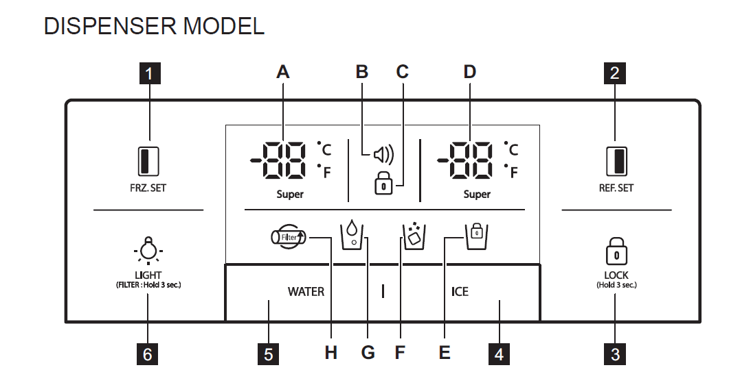

Reset the water filter:

In order to eliminate the blinking icon on the display please do the following steps:

1. Exchange the water filter *(optionally, depending on how often the Ice & Water function was used*)
2. Press the 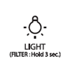 button for 3 seconds

***Note: Once the filter alarm is reset, the appliance will start counting the next 6 months of refrigerator use. (the appliance starts counting from the time the appliance got connected to the electricity) After six month the Filter Alarm Icon will start blinking again. It is recommended to change the filer or to make a reset depending on how often the Ice & Water function was used.***

Please visit our web shop to find cleaning products, accessories and spare parts to your products.

(webshop)